Practice Assignment – Drawing with Loops

- Create a component that makes sprays of lines vertically instead of horizontally

- Using a single loop, create a component that makes a spray of lines starting in the top left corner and extend evenly spaced across the bottom and right sides:
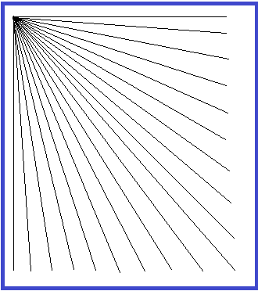

- Create a component that makes a bulls eye of alternating colours. This should be done using a single loop:

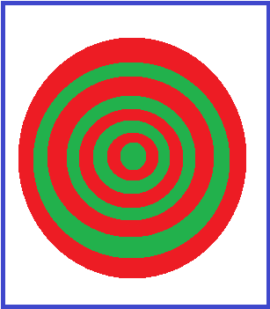

- Create a component that is completely filled with small circles
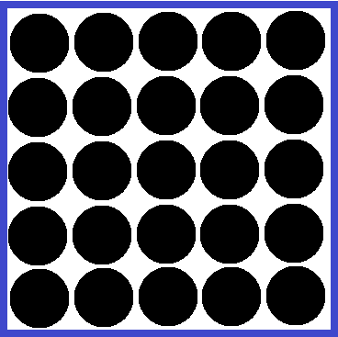

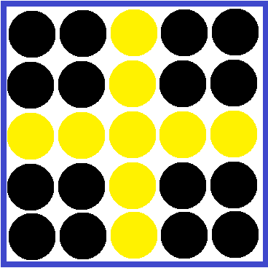
  - Make one row and column a “Cross” of circles that are of a different colour

- Create a checkerboard component.

